Quick Start: Filter Actions

Use the Filter Actions filter to show related information between a source sheet and one or more target sheets. This type of action works well when you are building guided analytical paths through a workbook or in dashboards that filter from a master sheet to show more details.

**1 Select a View to Use as a Filter**

On a dashboard, click the drop-down menu of a sheet and select **Use as Filter**.

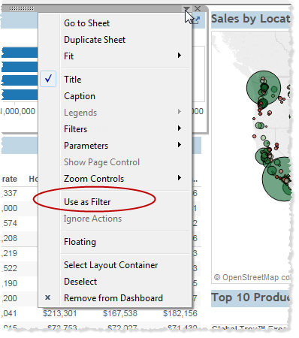

A filter action is created so when you select a mark in the view the rest of the dashboard updates to show only related data.

**2 Edit the Action**

Select **Dashboard**> **Actions**to open the **Actions** dialog box. Select an action and then click **Edit**.

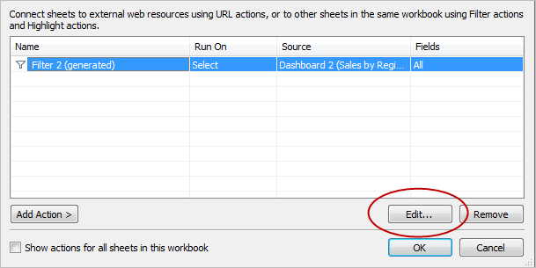

Any action you create displays in the **Actions** dialog box. You can add Filter, Highlight, or URL actions.

**3 Specify the Action Settings**

In the **Edit Filter Action** dialog box, select the source sheets, target sheets, and the fields to filter. You can also select whether to run the action when you hover, select, or right-click the source sheet. When finished, click **OK**.

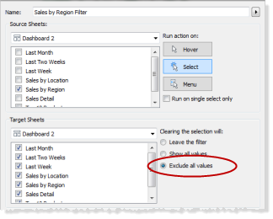

To remove the filter when you deselect the data in the source sheet, select **Exclude All Values** in the **Clearing the Selection Will** section.

**4 See it in Action**

Hover, select, or right-click the source sheet and watch the other sheets update to show related data.

